**i) RELAY INTERFACE USING DAQ CARD:**

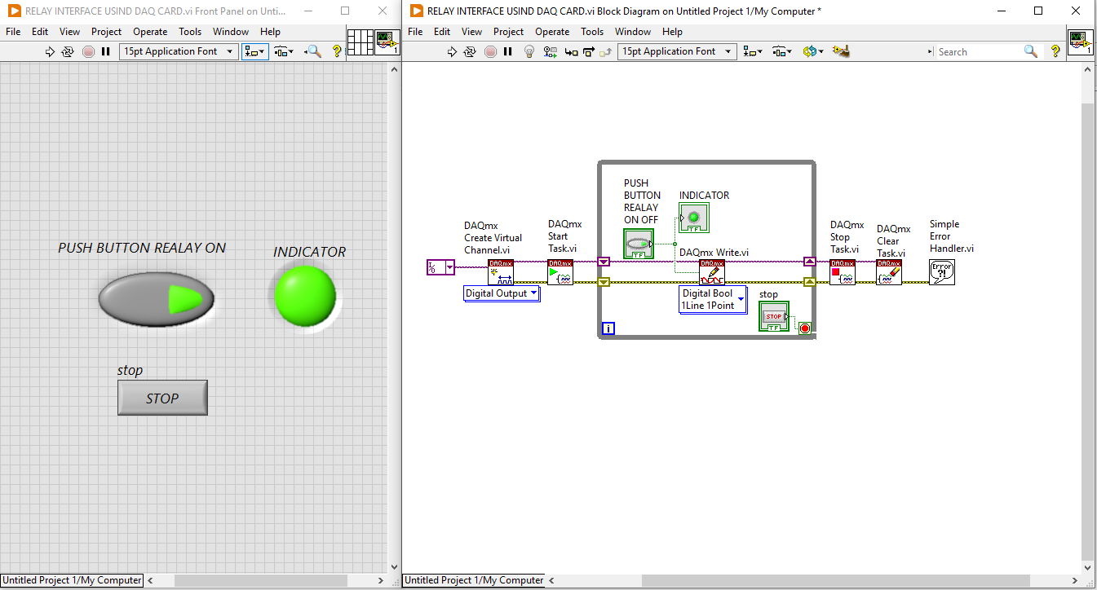

**ii) IR PAIR INTERFACE USING DAQ CARD:**

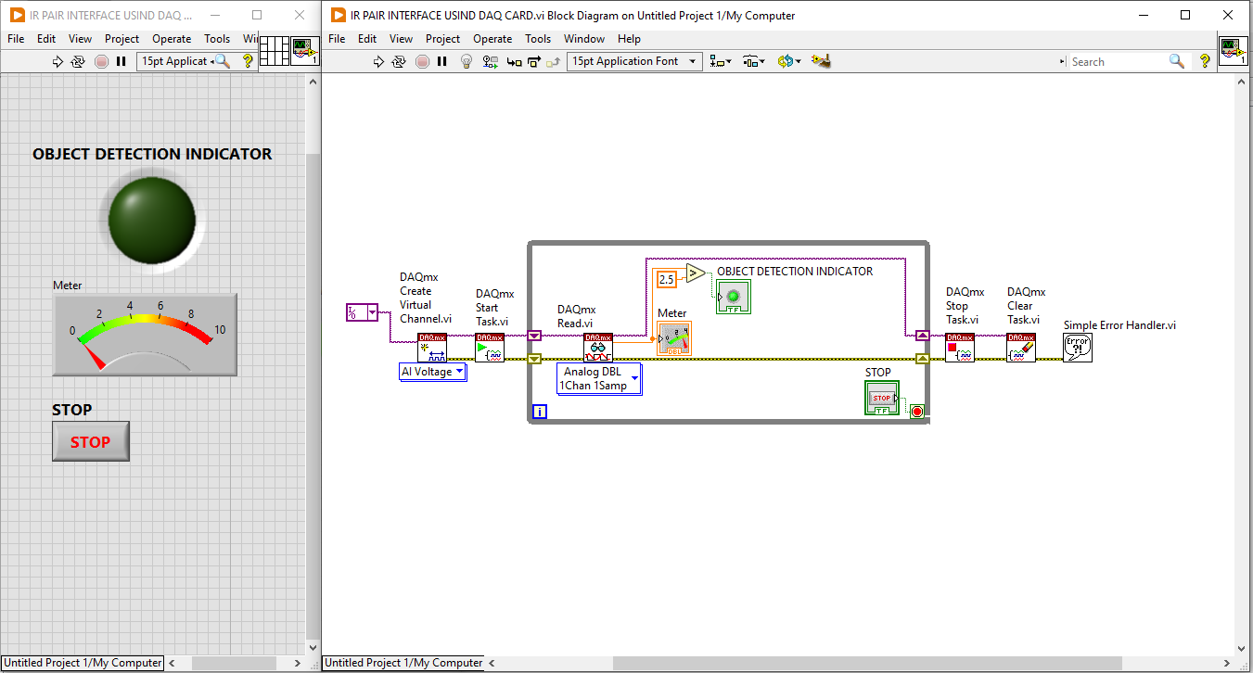

**iii) DC MOTER SPEED CONTROL USING DAQ CARD:**